COGNIZANT WEEK 3
BHUMISTHA SAHOO

Exercise 1: PL/SQL Control Structures

Create Customers Table
CREATE TABLE Customers (
CustomerID NUMBER PRIMARY KEY,
CustomerName VARCHAR2(50),
Age NUMBER,
Balance NUMBER(12,2),
IsVIP VARCHAR2(5)
);
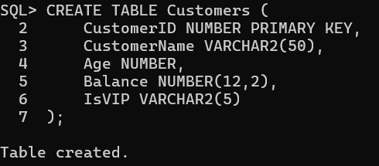

Create Loans Table
CREATE TABLE Loans (
LoanID NUMBER PRIMARY KEY,
CustomerID NUMBER,
InterestRate NUMBER(5,2),
DueDate DATE,
FOREIGN KEY (CustomerID) REFERENCES Customers(CustomerID)
);
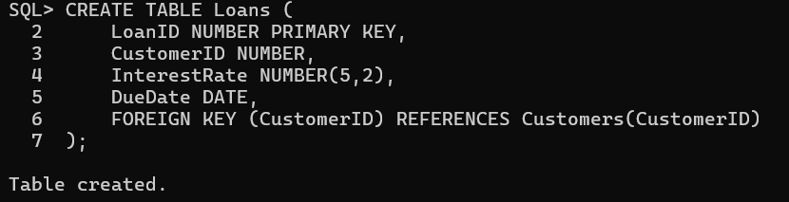

Insert Customers
INSERT INTO Customers VALUES (1001,'Rajesh Kumar',65,1500000,'FALSE');
INSERT INTO Customers VALUES (1002,'Priya Sharma',34,850000,'FALSE');
INSERT INTO Customers VALUES (1003,'Amit Verma',72,2250000,'FALSE');
INSERT INTO Customers VALUES (1004,'Neha Reddy',29,450000,'FALSE');
INSERT INTO Customers VALUES (1005,'Suresh Patel',61,980000,'FALSE');
INSERT INTO Customers VALUES (1006,'Ananya Gupta',41,1200000,'FALSE');
INSERT INTO Customers VALUES (1007,'Vikram Singh',55,350000,'FALSE');
INSERT INTO Customers VALUES (1008,'Meera Nair',67,1850000,'FALSE');
COMMIT;
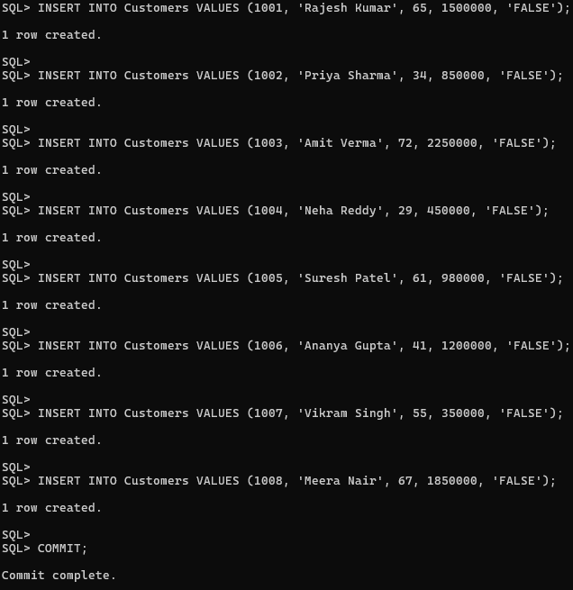

Insert Loans
INSERT INTO Loans VALUES (5001,1001,9.50,SYSDATE+12);
INSERT INTO Loans VALUES (5002,1002,10.25,SYSDATE+45);
INSERT INTO Loans VALUES (5003,1003,8.75,SYSDATE+20);
INSERT INTO Loans VALUES (5004,1004,11.00,SYSDATE+55);
INSERT INTO Loans VALUES (5005,1005,9.25,SYSDATE+8);
INSERT INTO Loans VALUES (5006,1006,10.00,SYSDATE+28);
INSERT INTO Loans VALUES (5007,1007,11.50,SYSDATE+90);
INSERT INTO Loans VALUES (5008,1008,8.50,SYSDATE+15);
COMMIT;
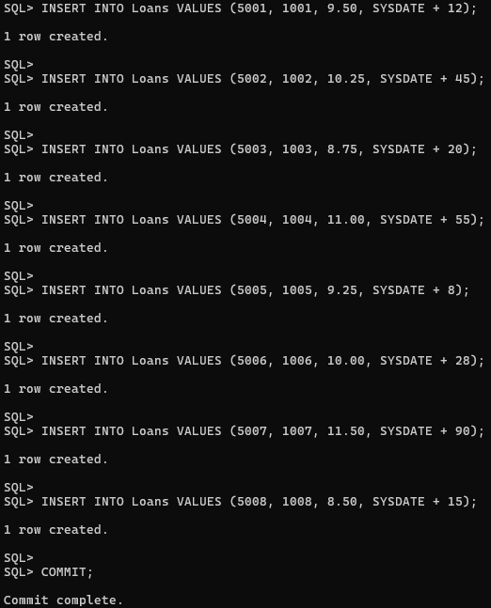

Scenario 1
SET SERVEROUTPUT ON;
BEGIN
FOR customer_record IN (SELECT c.CustomerID,c.Age,l.LoanID FROM Customers c JOIN Loans l ON c.CustomerID=l.CustomerID)
LOOP
IF customer_record.Age>60 THEN
UPDATE Loans SET InterestRate=InterestRate-1 WHERE LoanID=customer_record.LoanID;
END IF;
END LOOP;
COMMIT;
DBMS_OUTPUT.PUT_LINE('Interest Rate Updated Successfully');
END;
/
SELECT * FROM Loans;
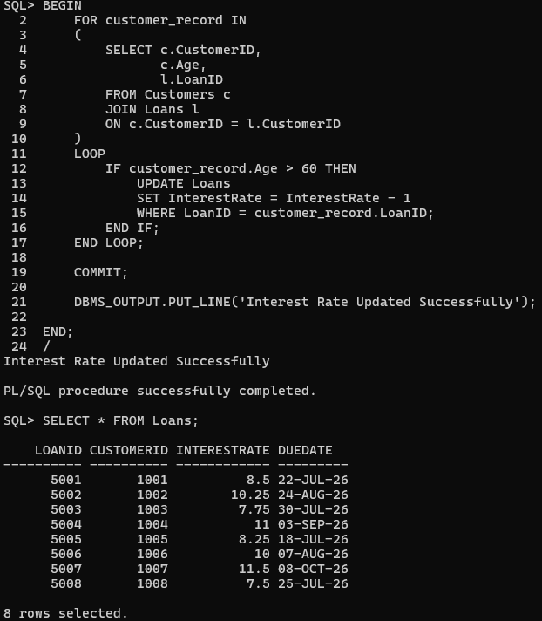

Scenario 2
SET SERVEROUTPUT ON;
BEGIN
FOR customer_record IN (SELECT CustomerID,Balance FROM Customers)
LOOP
IF customer_record.Balance>1000000 THEN
UPDATE Customers SET IsVIP='TRUE' WHERE CustomerID=customer_record.CustomerID;
END IF;
END LOOP;
COMMIT;
DBMS_OUTPUT.PUT_LINE('VIP Status Updated Successfully');
END;
/
SELECT * FROM Customers;
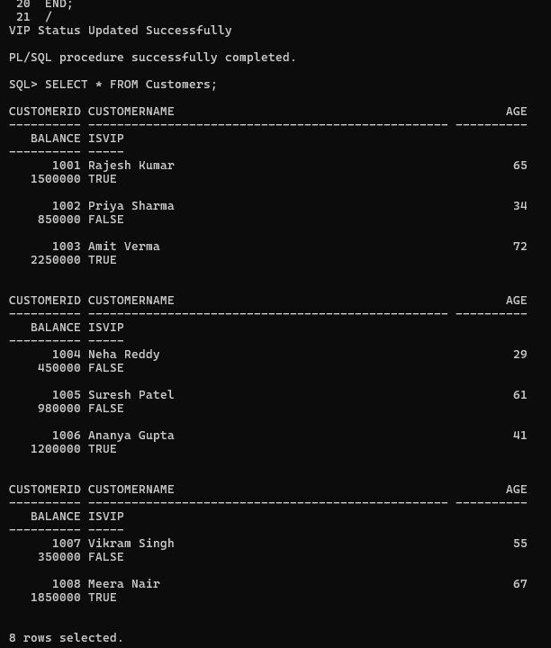

Scenario 3
SET SERVEROUTPUT ON;
BEGIN
FOR loan_record IN (SELECT c.CustomerName,l.LoanID,l.DueDate FROM Customers c JOIN Loans l ON c.CustomerID=l.CustomerID WHERE l.DueDate BETWEEN SYSDATE AND SYSDATE+30)
LOOP
DBMS_OUTPUT.PUT_LINE('Reminder: Dear '||loan_record.CustomerName||', Loan ID '||loan_record.LoanID||' is due on '||TO_CHAR(loan_record.DueDate,'DD-MON-YYYY'));
END LOOP;
END;
/
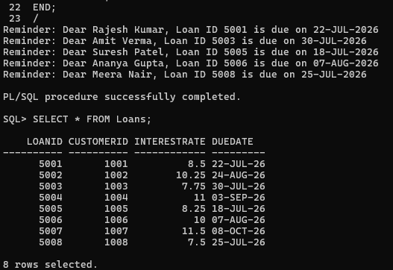

Exercise 3: Stored Procedures

Create Accounts Table
CREATE TABLE Accounts(
AccountID NUMBER PRIMARY KEY,
CustomerName VARCHAR2(50),
AccountType VARCHAR2(20),
Balance NUMBER(12,2)
);
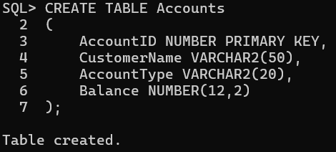

Insert Sample Data
INSERT INTO Accounts VALUES(101,'Rajesh Kumar','Savings',250000);
INSERT INTO Accounts VALUES(102,'Priya Sharma','Current',180000);
INSERT INTO Accounts VALUES(103,'Amit Verma','Savings',320000);
INSERT INTO Accounts VALUES(104,'Neha Reddy','Savings',150000);
INSERT INTO Accounts VALUES(105,'Vikram Singh','Current',275000);
INSERT INTO Accounts VALUES(106,'Meera Nair','Savings',410000);
COMMIT;
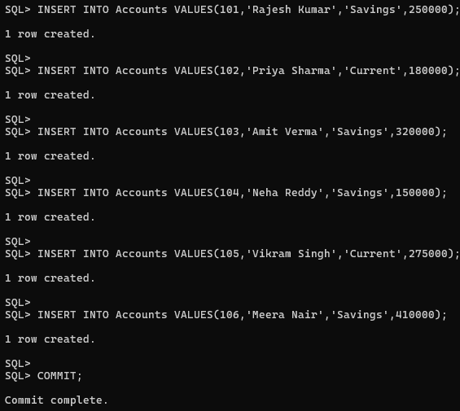
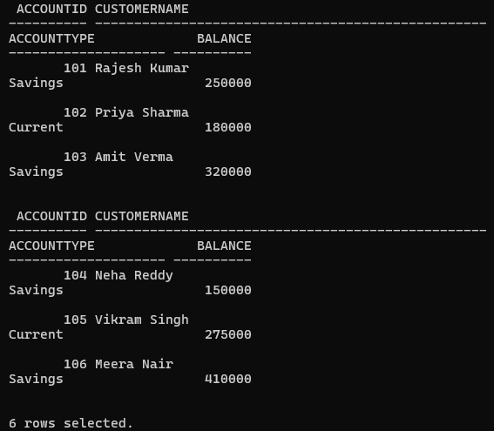

Scenario 1: ProcessMonthlyInterest
CREATE OR REPLACE PROCEDURE ProcessMonthlyInterest
AS
BEGIN
UPDATE Accounts
SET Balance = Balance + (Balance * 0.01)
WHERE AccountType='Savings';
COMMIT;
END;
/
EXEC ProcessMonthlyInterest;
SELECT * FROM Accounts;
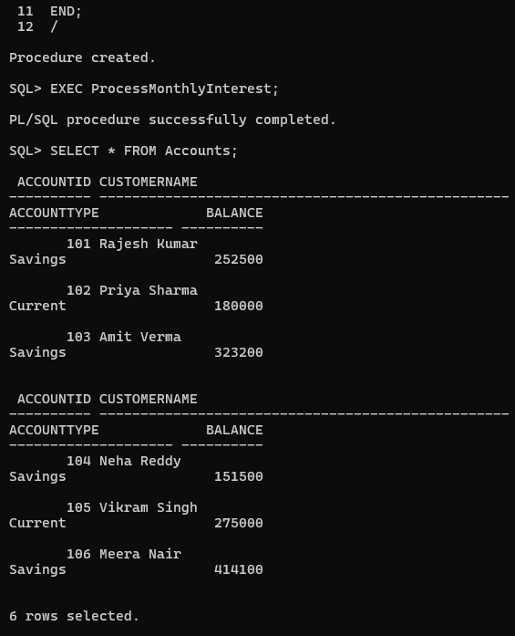

Create Employees Table
CREATE TABLE Employees(
EmployeeID NUMBER PRIMARY KEY,
EmployeeName VARCHAR2(50),
Department VARCHAR2(30),
Salary NUMBER(10,2)
);
INSERT INTO Employees VALUES(201,'Ankit Sharma','Loans',55000);
INSERT INTO Employees VALUES(202,'Sneha Reddy','Accounts',62000);
INSERT INTO Employees VALUES(203,'Rahul Verma','Loans',60000);
INSERT INTO Employees VALUES(204,'Pooja Patel','IT',70000);
INSERT INTO Employees VALUES(205,'Arjun Singh','Loans',58000);
INSERT INTO Employees VALUES(206,'Kavya Nair','Accounts',65000);
COMMIT;
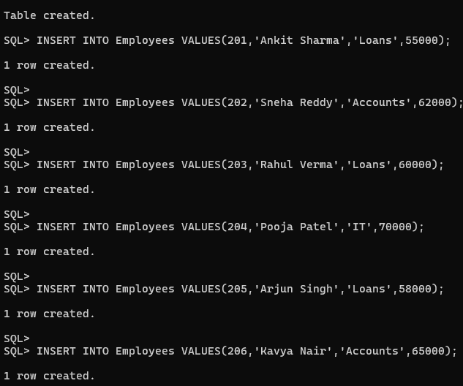
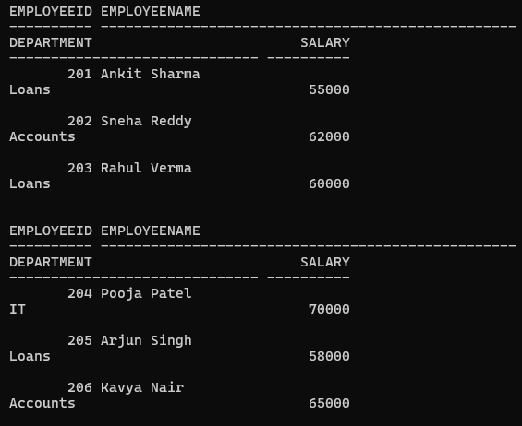

Scenario 2: UpdateEmployeeBonus
CREATE OR REPLACE PROCEDURE UpdateEmployeeBonus(
dept IN VARCHAR2,
bonus IN NUMBER)
AS
BEGIN
UPDATE Employees
SET Salary = Salary + (Salary * bonus / 100)
WHERE Department = dept;
COMMIT;
END;
/
EXEC UpdateEmployeeBonus('Loans',10);
SELECT * FROM Employees;
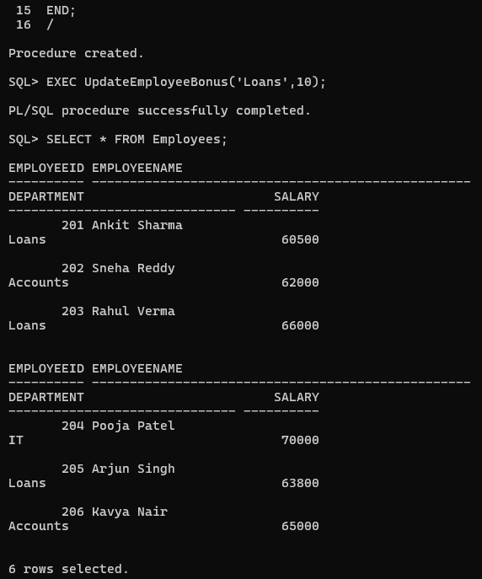

Scenario 3: TransferFunds
SET SERVEROUTPUT ON;
CREATE OR REPLACE PROCEDURE TransferFunds(
FromAccount IN NUMBER,
ToAccount IN NUMBER,
Amount IN NUMBER)
AS
AvailableBalance NUMBER;
BEGIN
SELECT Balance INTO AvailableBalance
FROM Accounts
WHERE AccountID=FromAccount;
IF AvailableBalance>=Amount THEN
UPDATE Accounts
SET Balance=Balance-Amount
WHERE AccountID=FromAccount;
UPDATE Accounts
SET Balance=Balance+Amount
WHERE AccountID=ToAccount;
COMMIT;
DBMS_OUTPUT.PUT_LINE('Fund Transfer Successful');
ELSE
DBMS_OUTPUT.PUT_LINE('Insufficient Balance');
END IF;
END;
/
EXEC TransferFunds(101,104,50000);
SELECT * FROM Accounts;
